Marais des Cygnes District 4-H Member Achievement Pin Record Form
Information about the Member Achievement Pins can be found on the Marais des Cygnes Website under 4-H Youth Development/Pin Awards. Use this form to keep track of the Member Achievement Pin Awards that you have received. Each year you receive a pin, write the date you received the pin in the blank.
Guidelines for Marais des Cygnes Member Achievement Pins are:
- Only ONE Achievement Pin can be received by a 4-H member each year. 4-Hers may receive Special Awards such as the Kansas 4-H Key Award or I Dare You Award with a Member Achievement Pin.
- A pin may be skipped, but once a pin is skipped, a 4-Her may not go back and apply for it. For example: If a member received the Bronze Pin in 2016 and the Emerald in 2017, he/she cannot go back and apply for the Clover Pin in 2018.
- INDEPENDENT 4-H Members are NOT eligible for Member Achievement Pins or Special Awards.

4-H’ers Name: Click or tap here to enter text. 4-H Club: Click or tap here to enter text.
Member Achievement Pin | Date Received
- Membership Pin | Click or tap here to enter text.
- Bronze Pin | Click or tap here to enter text.
- Clover Pin | Click or tap here to enter text.
- Emerald Pin | Click or tap here to enter text.
- Silver Pin | Click or tap here to enter text.
- Silver Guard Pin | Click or tap here to enter text.
- Leadership Pin | Click or tap here to enter text.
- Gold Pin | Click or tap here to enter text.
- Gold Guard Pin | Click or tap here to enter text.
- 10 Year Pin | Click or tap here to enter text.
- 11 Year Pin | Click or tap here to enter text.
- 12 Year Pin | Click or tap here to enter text.
I Dare You Award (Minimum 4-H age 14) | Click or tap here to enter text.
Key Award (Minimum 4-H Age 16) | Click or tap here to enter text.
Keep this form in the back of your Record Book or some other safe place.

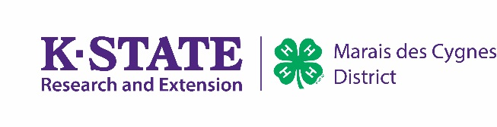
Kansas State University is committed to making its services, activities and programs accessible to all participants. If you have special requirements due to a physical, vision, or hearing disability, contact Karla Hightower, 913-294-4306.
Kansas State University Agricultural Experiment Station and Cooperative Extension Service
K-State Research and Extension is an equal opportunity provider and employ

